BENEFITS OF ADAPTING TO MEDCARE PROJECT:

- CENTRALISED DATA OF ALL THE HOPITALS AND THEIR PATIENTS LINKED WITH MEDCARE.

- INCASE OF PATIENT TO SHIFT HIS/HER MEDICATION, HE/SHE JUST HAVE TO CARRY AN ID/LINK TO HIS RECORD IN THE DATABASE

- IN 2001, THERE WERE ABOUT 2 MILLION CASES OF ADVERSE DRUG REACTIONS, GRADUALLY THERE HAS BEEN AN INCREASE IN QUANTITY, SO, THE ANOTHER MAIN AGENDA OF MEDCARE IS TO DECREASE THE QUANTITY OF SUCH CASES.
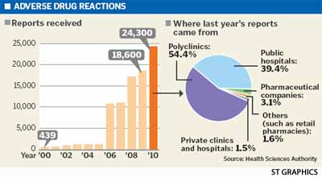

- SYSTEMATIC IMPLEMENTATION OF MEDCARE CAN HELP TO INCREASE THE TIME EFFICIENCY OF DOCTORS TO RETRIEVE THE COMPLETE HISTORY OF PATIENTS, WHICH IS BENEFICIAL OF PATIENTS AS WELL .

- AUTOMATIC DATA ANALYSIS FEATURE OF MEDCARE CAN PREDICT BETTER SALTS FOR PRESCRIPTION WHICH MAY OR MAY NOT BE CLASSIFIED, AND THEREFORE HELP THE DOCTOR IN BETTER DECISION MAKING FOR PRESCRIPTION AND HELP THE PATIENT TO GET A GOOD CURE OF DISEASE .

